**CS825-001, Spring/Summer 2020**

**Assignment 4- Part 2**

**Submitted to Dr. Xue Dong Yang**

**By**

**Adarsh Koppa Manjunath**

**200397257**

Question 2-

A) divide the spectrum into a set of rings

Set of Rings Method - Computation Performed with the input **car image**

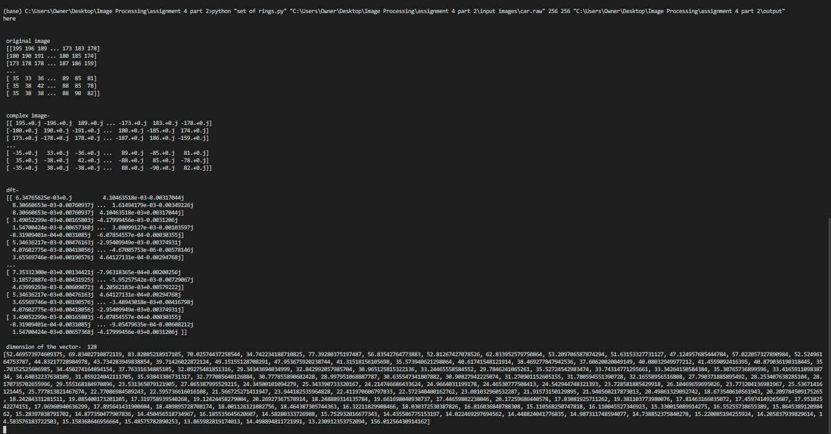

Fig 1- Computation Performed with the input **car image using Set of Rings**

Set of Rings Method - Frequency Histogram using set of rings for car image

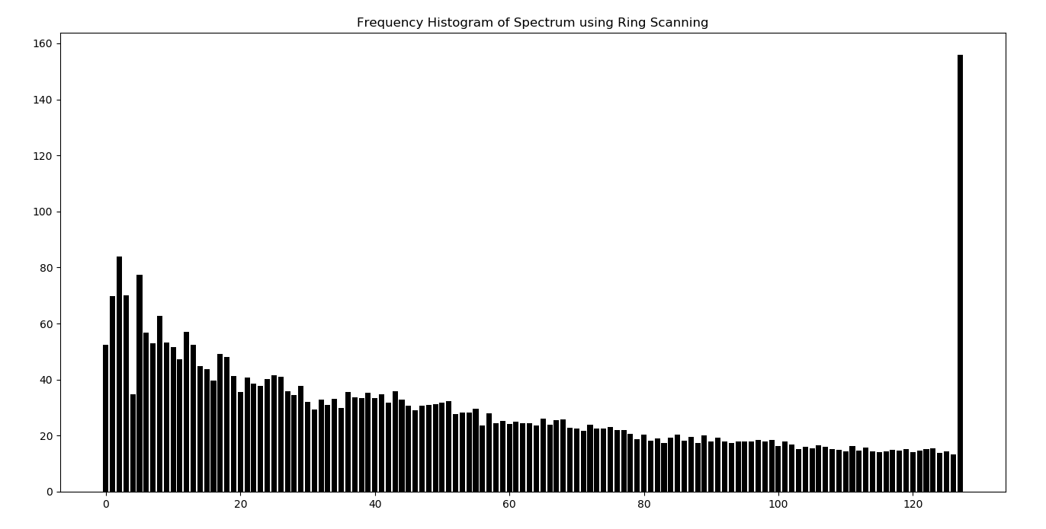

Fig 2- Frequency Histogram using set of rings for car image

Set of Rings Method - Computation Performed with the input **square 256 image**

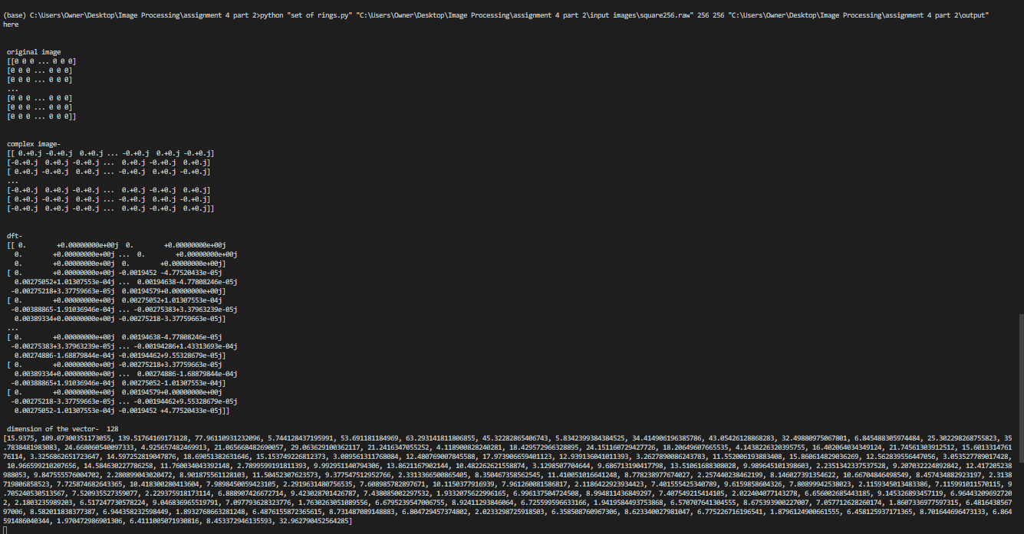

**Fig 3-** Computation Performed with the input **square 256 image**

**Set of Rings Method - Frequency of histogram using set of rings for square256 image**

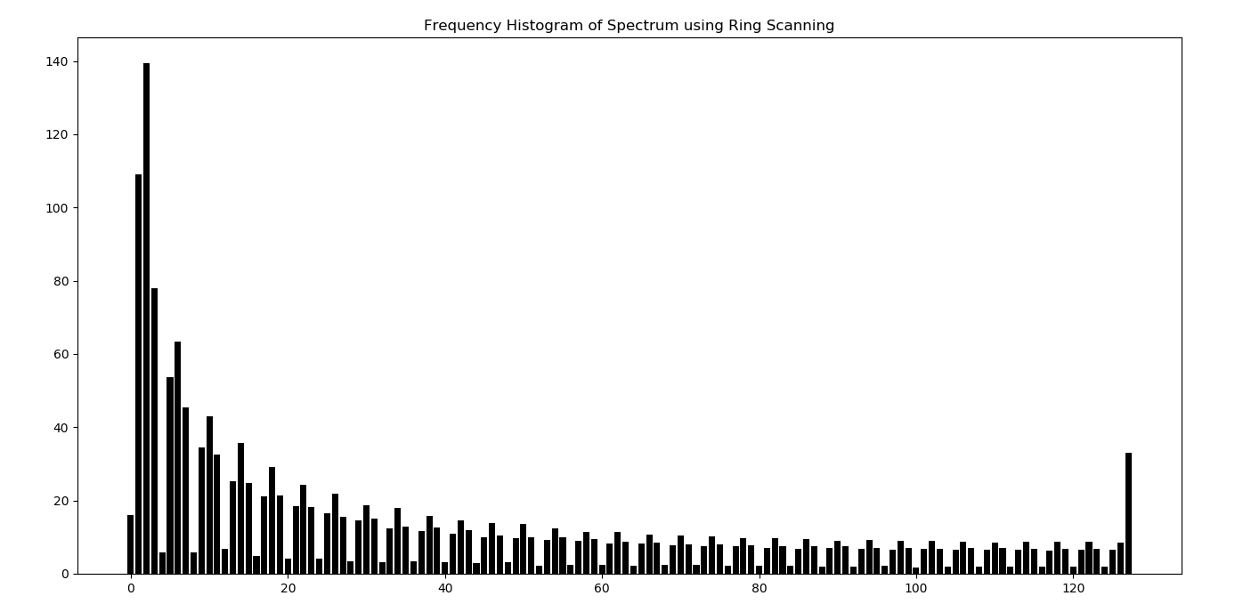

**Fig 4- Frequency of histogram using set of rings for square256 image**

**2) B)** divide the spectrum into angular sectors

**Angular Sector Method- Computation performed for car image**

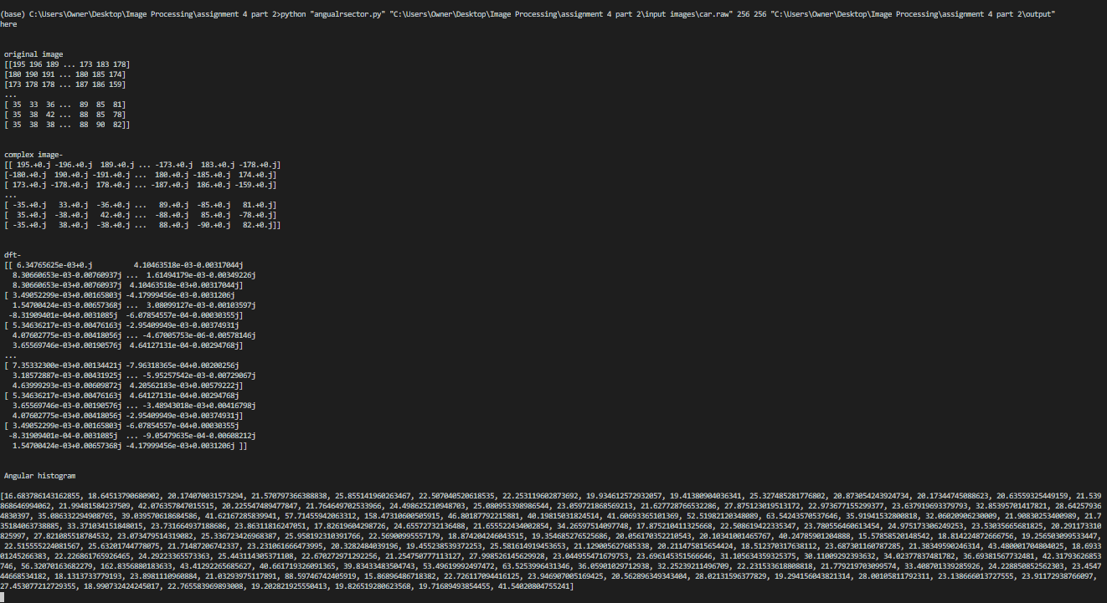

**Fig 5 - Computation performed for car image using angular sector method**

**Frequency histogram for car using angular method**

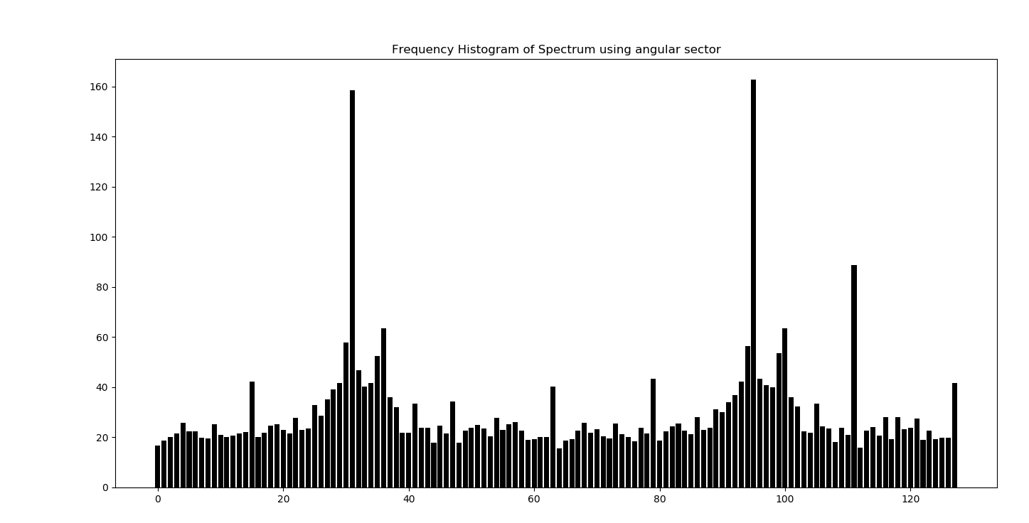

**Fig 6- Frequency histogram for car using angular method**

**Angular Sector Method - Computation performed for square256 image**

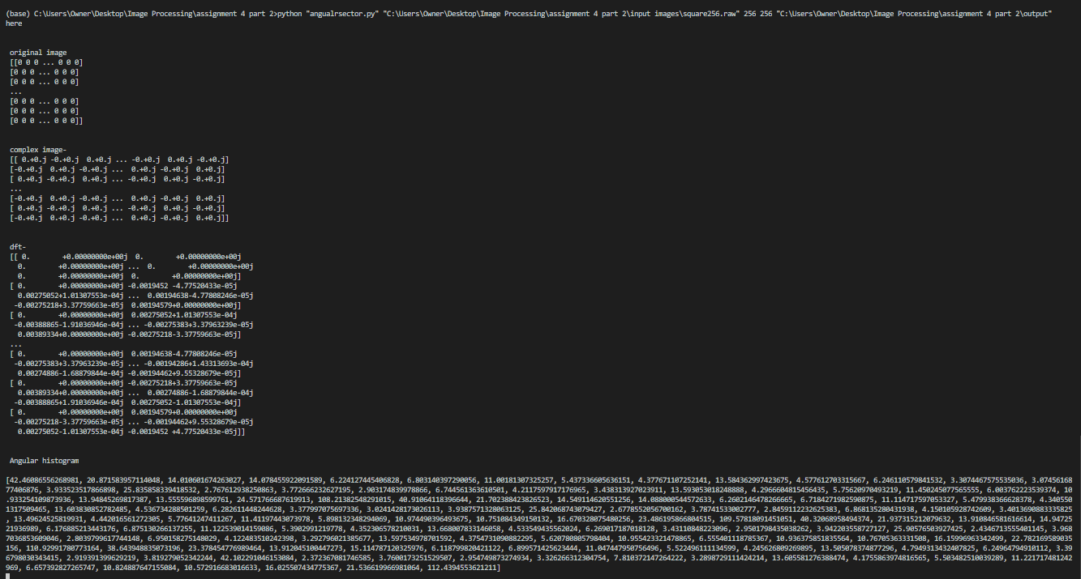

**Fig 7- Computation performed for square256 image using angular sector method**

**Angular Sector Method - Frequency histogram for square 256**

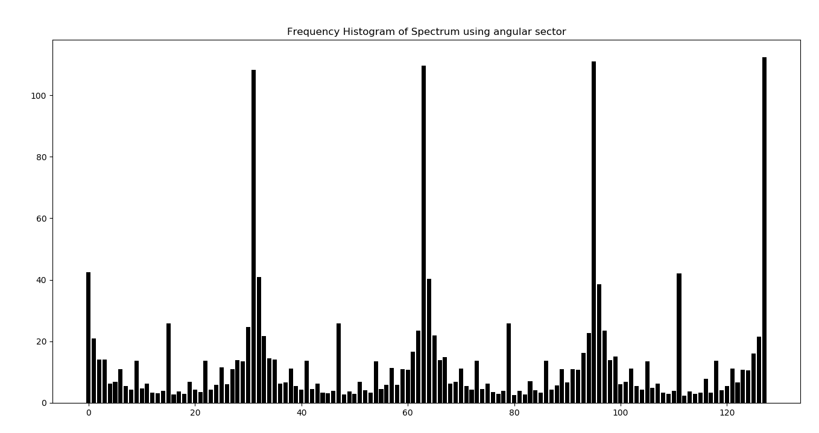

Fig 8 - **Frequency histogram for square 256 using angular sector method**

**Question 3)**

Below Screenshots include raw pixel images and computations performed. Low pass filter is performed with the cut off frequencies 30 and 70 for both car and square images. High pass filter is performed with the cut off frequencies 10 and 60 for both car and square images.

Below screenshots consists 8 executions. For every execution, there is a screenshot of raw image, screenshot of the filter and screenshot of the invers fft performed.

**Low pass filter**

**Low pass filter for car with the cutoff frequency 30**

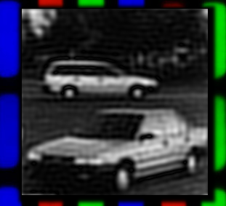

Fig 9- Low pass filter for car with the cutoff frequency 30

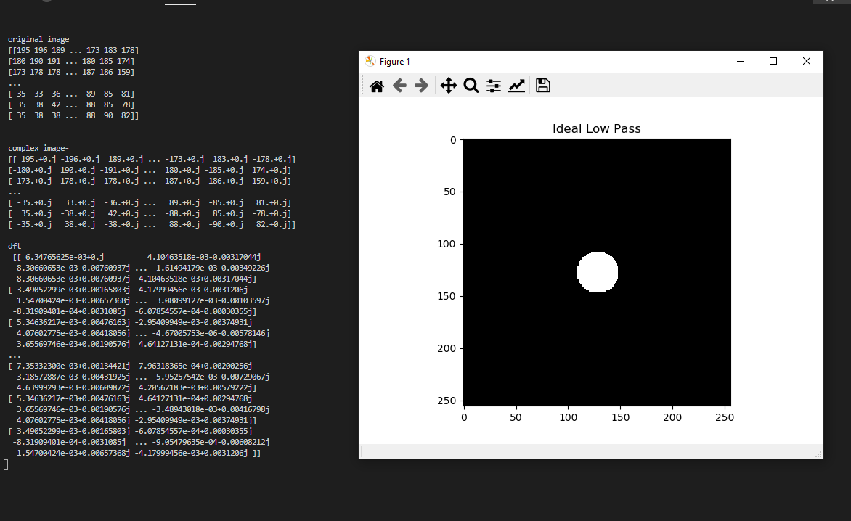

Fig 10- Low pass filter for the car with the cut off frequency 30

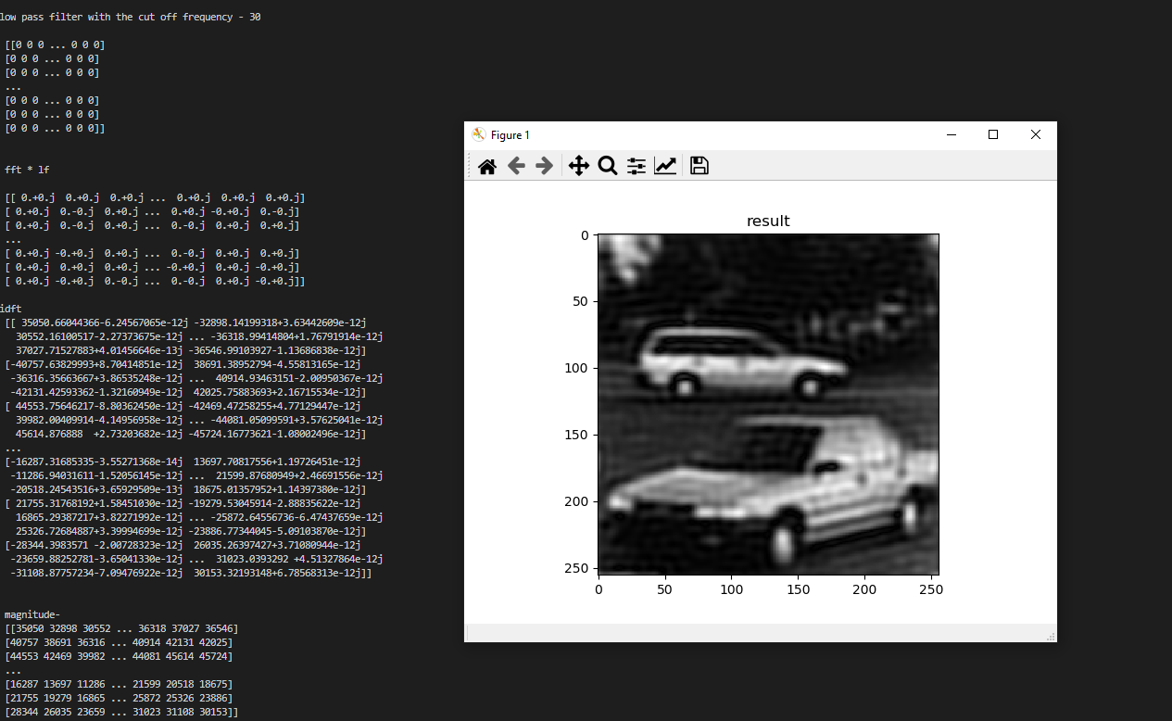

Fig 11- Low pass filter inverse fft result for the car with the cut off frequency 30

**Low pass filter for the car with the cut off frequency 70**

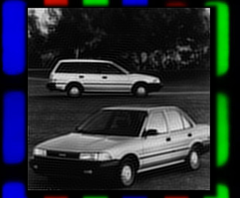

Fig 12- Low pass filter for the car with the cut off frequency 70

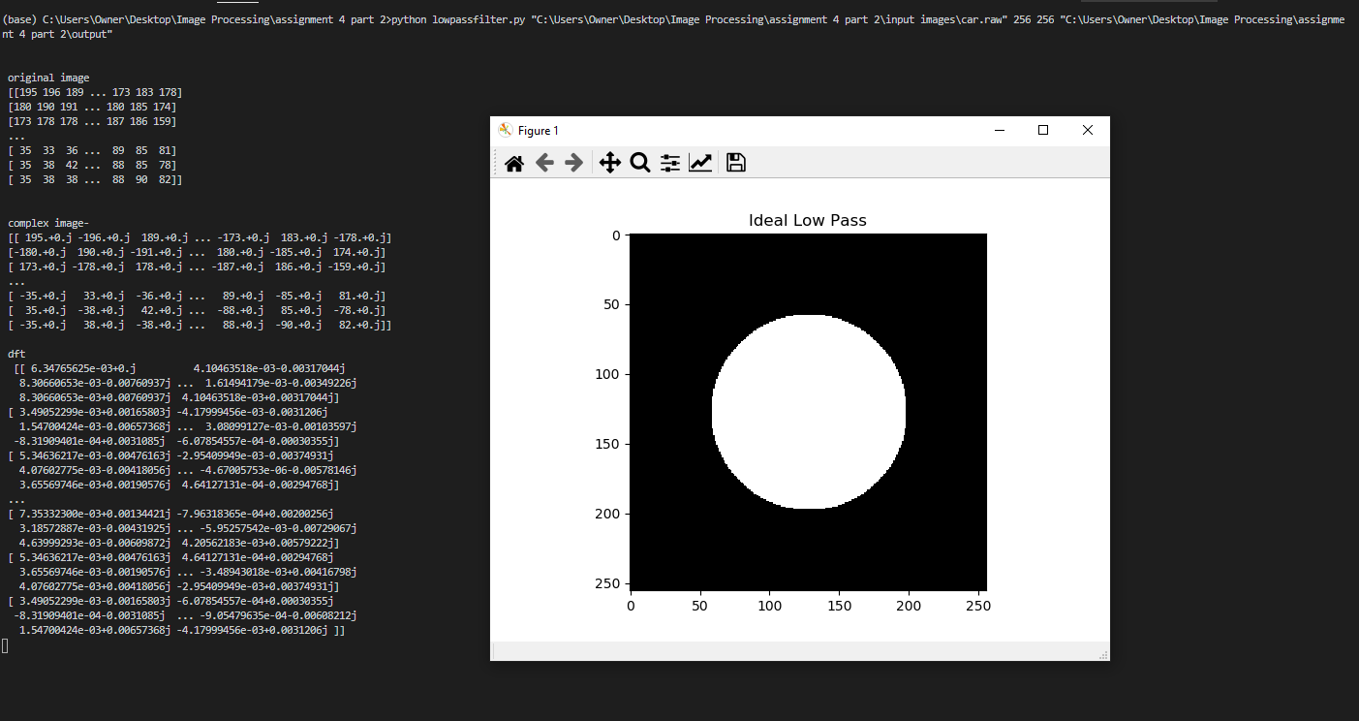

Fig 13- Low pass filter for the car with the cut off frequency 70

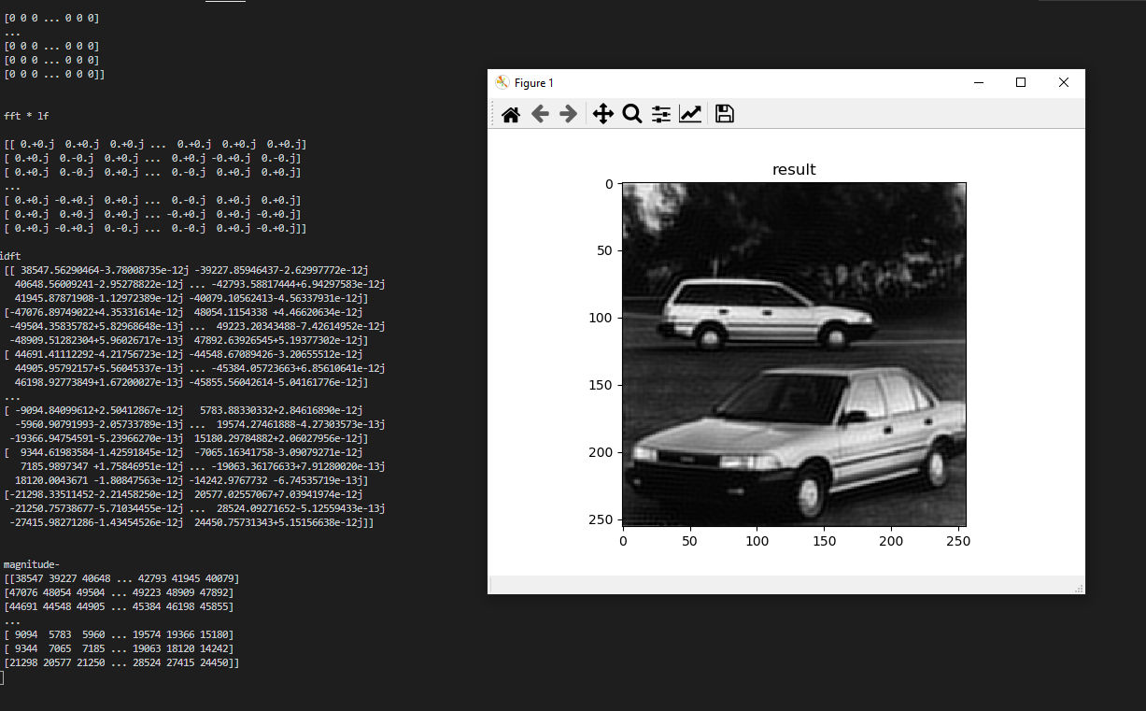

Fig 14- Low pass filter inverse fft result for the car with the cut off frequency 70

**Low pass filter for the square with the cut off frequency 30**

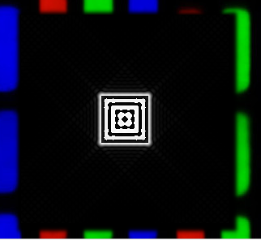

Fig 15 - Low pass filter for the square with the cut off frequency 30

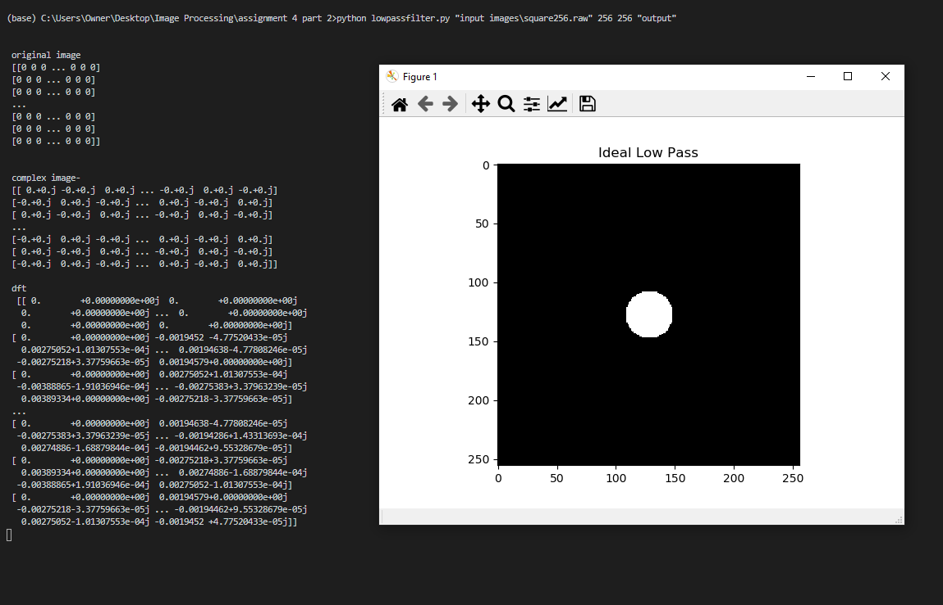

Fig 16- Low pass filter for the square with the cut off frequency 30

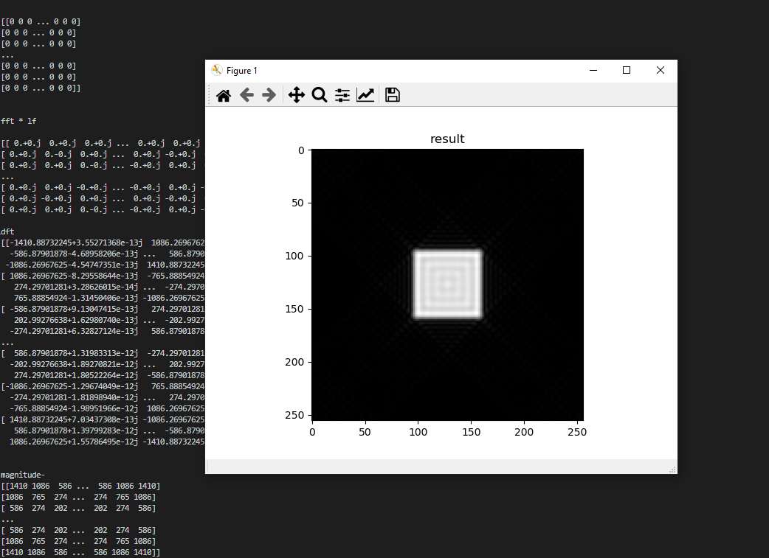

Fig 17- Low pass filter inverse fft result for the square with the cut off frequency 30

**Low pass filter for the square with the cut off frequency 70**

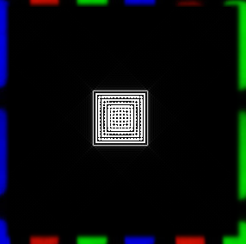

Fig 18 - Low pass filter for the square with the cut off frequency 70

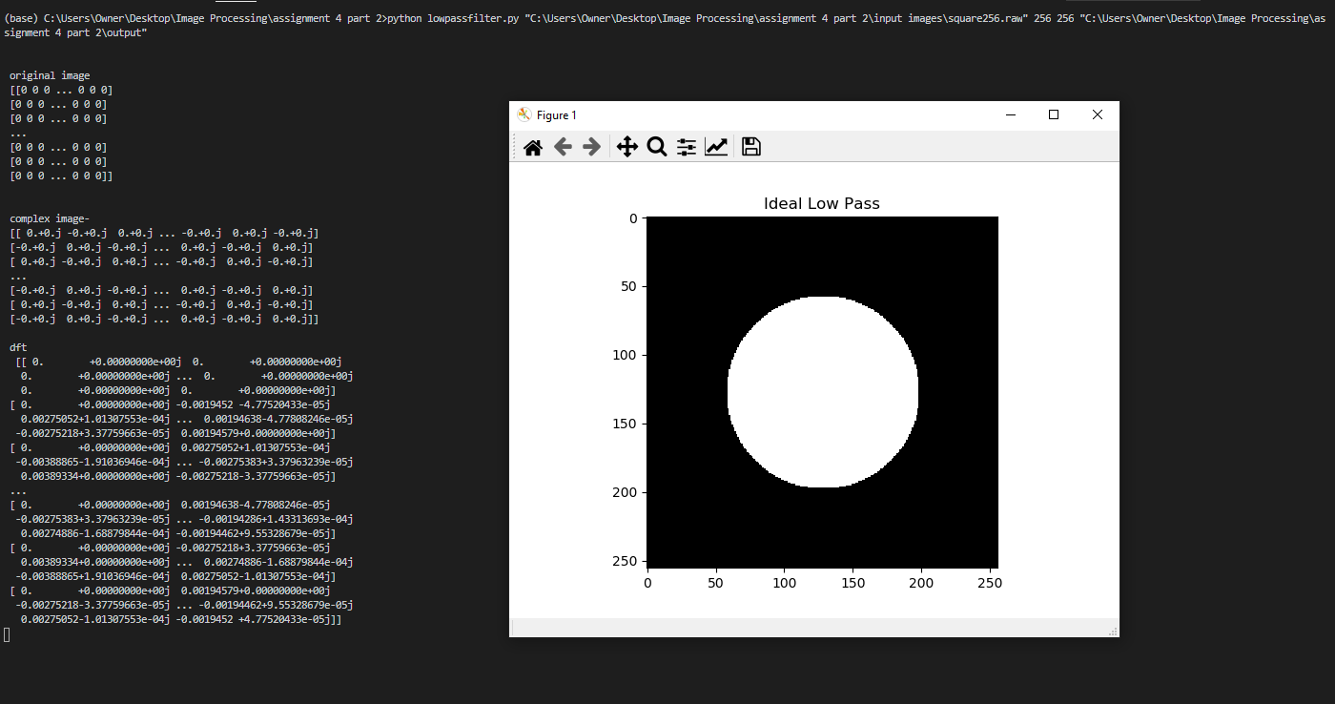

Fig 19- Low pass filter for the square with the cut off frequency 70

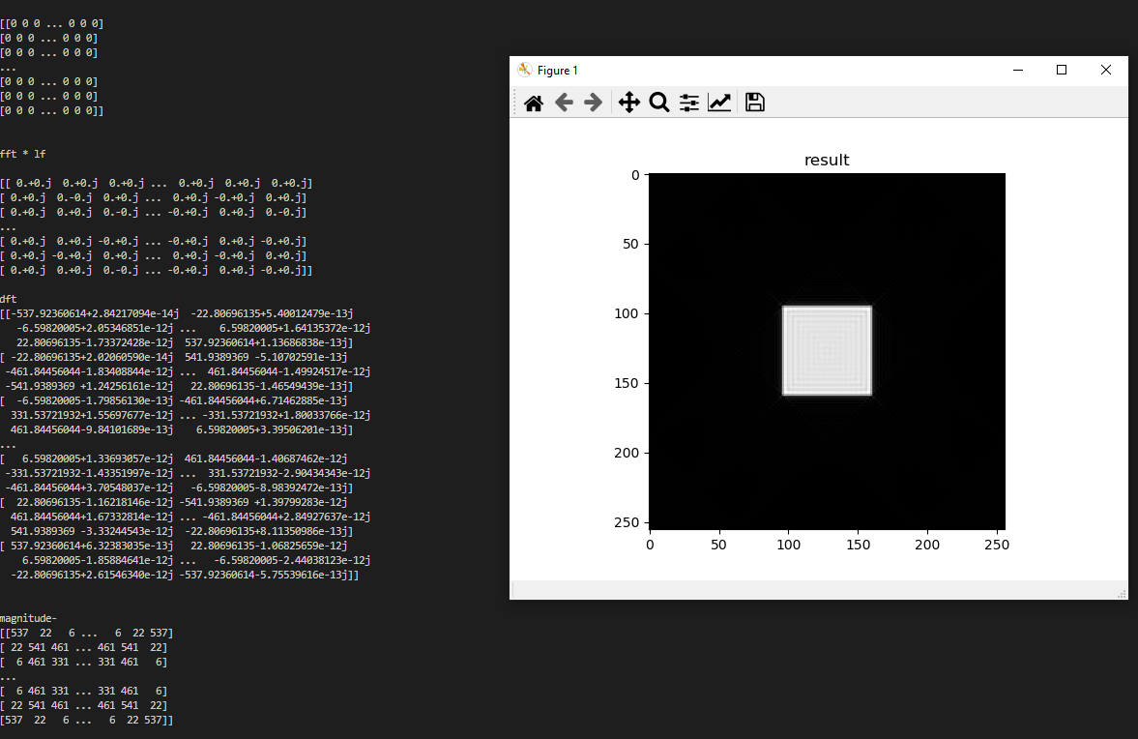

Fig 19- Low pass filter inverse fft result for the square with the cut off frequency 70

**High Pass Filter**

**High pass filter for the car with the cut off frequency 10**

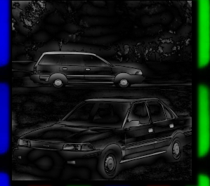

Fig 20- High pass filter for the car with the cut off frequency 10

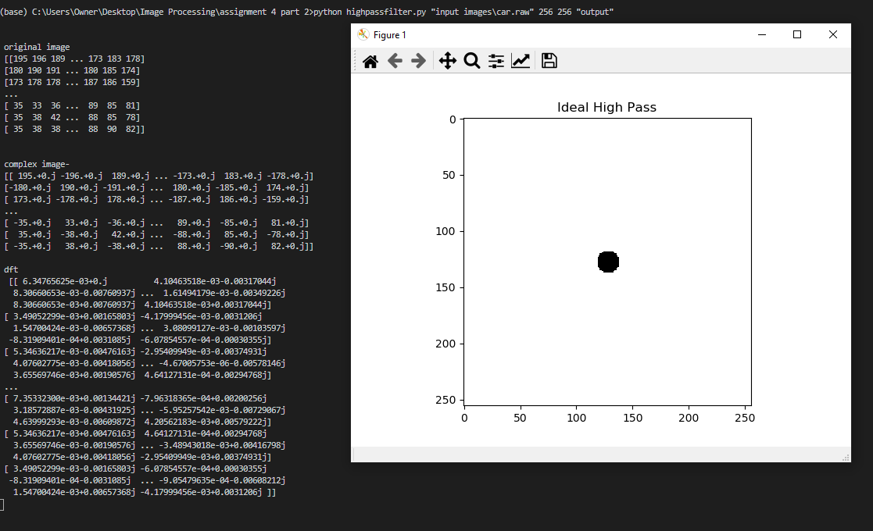

Fig 21- High Pass Filter for the car with the cut off frequency 10

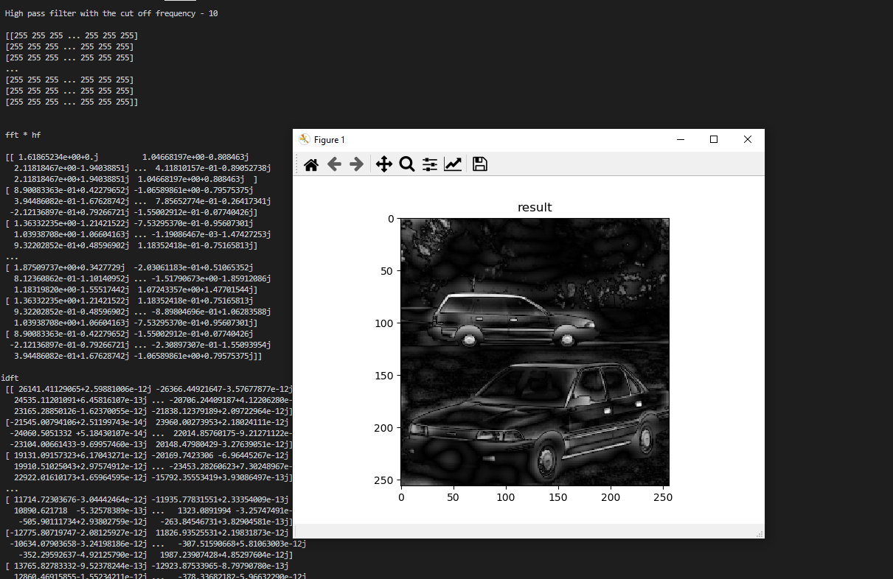

Fig 22- High Pass Filter inverse fft result for the car with the cut off frequency 10

**High pass filter for the car with the cut off frequency 60**

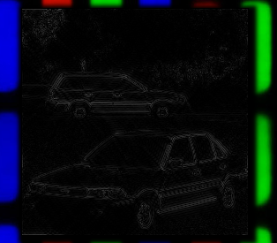

Fig 23 - High pass filter for the car with the cut off frequency 60

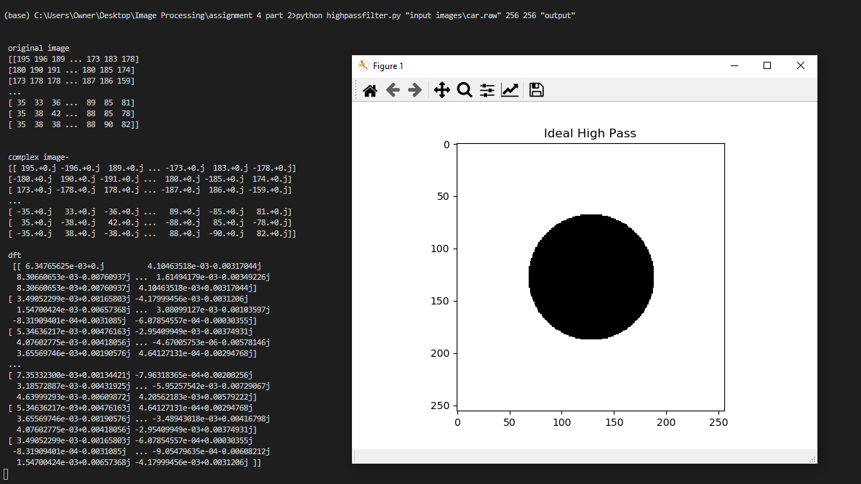

Fig 24- High Pass Filter for the car with the cut off frequency 60

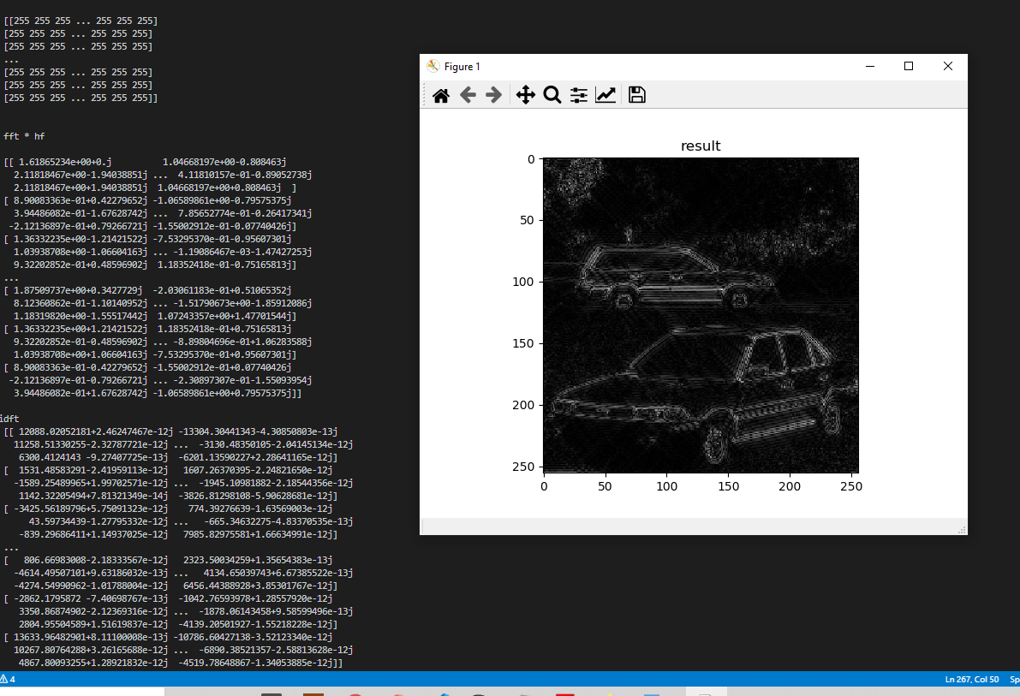

Fig 25- High Pass Filter for the car with the cut off frequency 60

**High pass filter for the square with the cut off frequency 10**

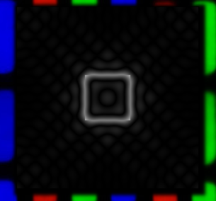

Fig 26- High pass filter for the square with the cut off frequency 10

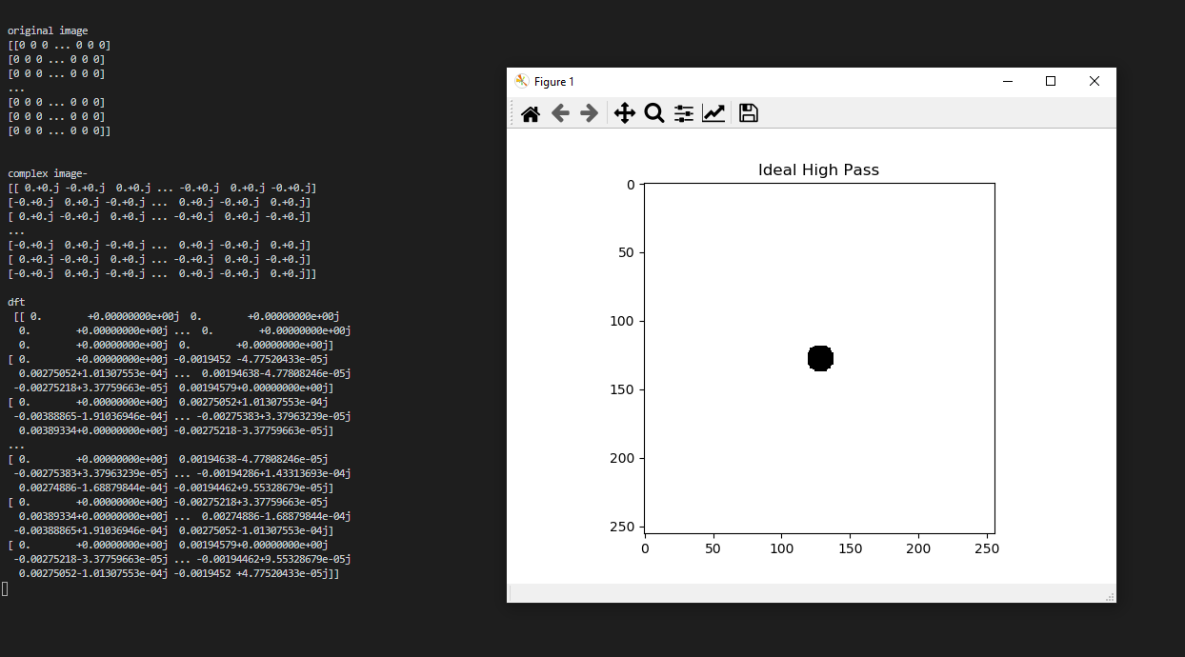

Fig 27- High Pass Filter for the square with the cut off frequency 10

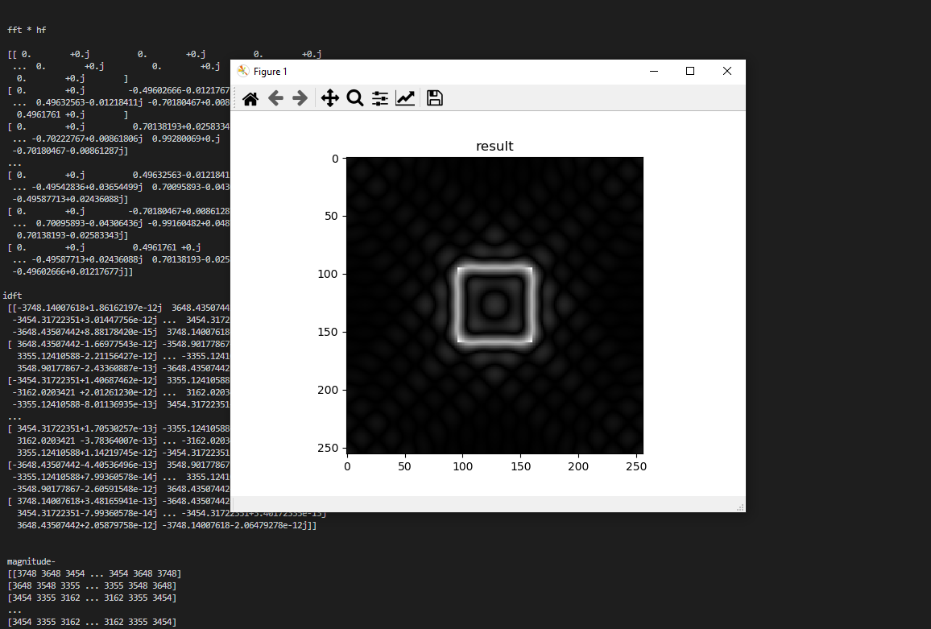

Fig 28- High Pass Filter inverse fft result for the square with the cut off frequency 10

**High Pass filter for the square with the cut off frequency 60**

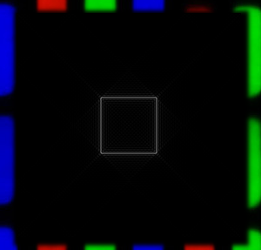

Fig 29 -High Pass filter for the square with the cut off frequency 60

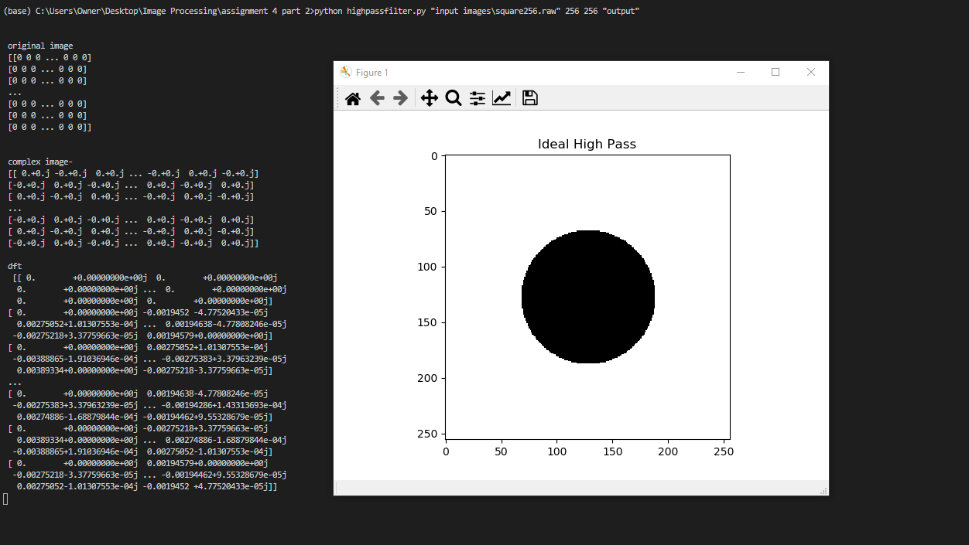

Fig 30- High Pass Filter for the square with the cut off frequency 60

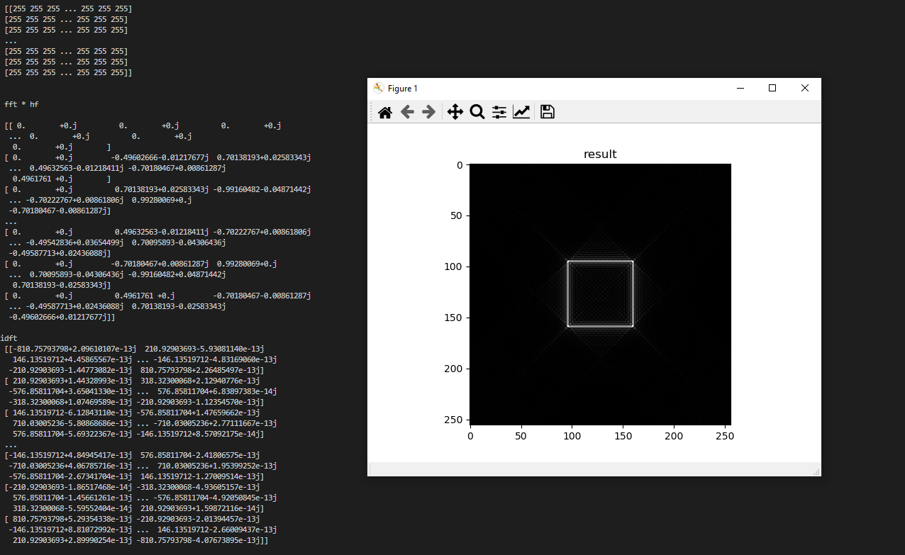

Fig 31- High Pass Filter inverse fft result for the square with the cut off frequency 60